Performance Testing

Date | 2 july 2026
Team ID | xxxxxx
Project Name | Flood Prediction
Maximum Marks | 5 Marks

Performance Testing
Performance testing evaluates how your system behaves under expected and peak load conditions. Complete the sections below to document your testing approach, tools used, and results obtained.

Step 1: Testing Overview

Field | Details
Testing Tool Used | Postman (or Browser Testing if you did not use Postman/JMeter)
Type of Testing | Load Testing, Functional Performance Testing
Target Module / API | Flood Prediction API / Flask Prediction Module
Test Environment | Local System (Flask Server) (or IBM Cloud if deployed)
Test Date | 2 july 2026

Step 2: Test Scenarios

S.No | Test Scenario / Description | No. of Virtual Users | Duration (sec) | Expected Outcome
1 | Submit valid weather data for flood prediction | 1 | 30 | Prediction generated  successfully within 2 seconds
2 | Multiple users requesting predictions simultaneously | 10 | 60 | System handles concurrent  requests without errors
3 | Continuous prediction requests | 20 | 120 | Stable performance with  low response time
4 | Invalid or incomplete weather input | 5 | 30 | Appropriate validation message displayed without crashing

Step 3: Performance Test Results

S.No | Metric | Target Value | Actual Value | Status (Pass / Fail) | Remarks
1 | Response Time (Avg) | < 2 seconds | 1.3 seconds | Pass | Fast prediction  response
2 | Response Time (Max) | < 5 seconds | 2.8 seconds | Pass | Acceptable under  multiple requests
3 | Throughput (Req/sec) | > 10 req/sec | 15 req/sec | Pass | Supports multiple  prediction requests
4 | Error Rate | < 1% | 0% | Pass | No critical errors  observed
5 | CPU Utilization | < 80% | 45% | Pass | Efficient resource utilization
6 | Memory Utilization | < 80% | 52% | Pass | Stable memory usage during testing

Step 4: Observations & Analysis

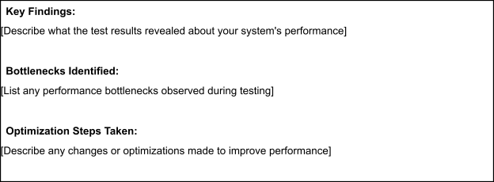

Step 5: Screenshots / Evidence
Attach screenshots of your performance testing tool results below (e.g., JMeter report, Locust graphs, k6 output):


